We will explore deployment of react apps from development to production.

ServerSide routing Vs Client Side routing.

Lazy Loading in ReactJS.

Load only that data which is required for the application.

Steps to add lazy loading to the project.

1. Import Suspense from react.
2. Add React.lazy(()=>import(‘./pages/QuoteDetail’));

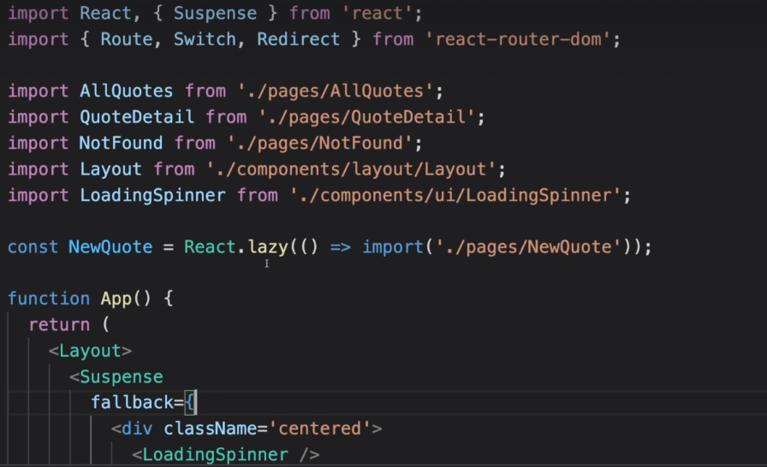

<Suspense fallback = {<div className=’centered’><LoadingSpinner>}

We need to get rid of the imports which we had mentioned before.

To generate a build in react we need to run the following command:-

Npm run build (check package.json file)

We want to upload the build folder that gets generated to production server.( if we want to deploy the application to firebase)

1. Install firebase-tools globally by using the following command.
2. Sudo npm install -g firebase-tools.
3. Firebase login
4. Firebase init
5. Select hosting: Configure and deploy Firebase Hosting sites.

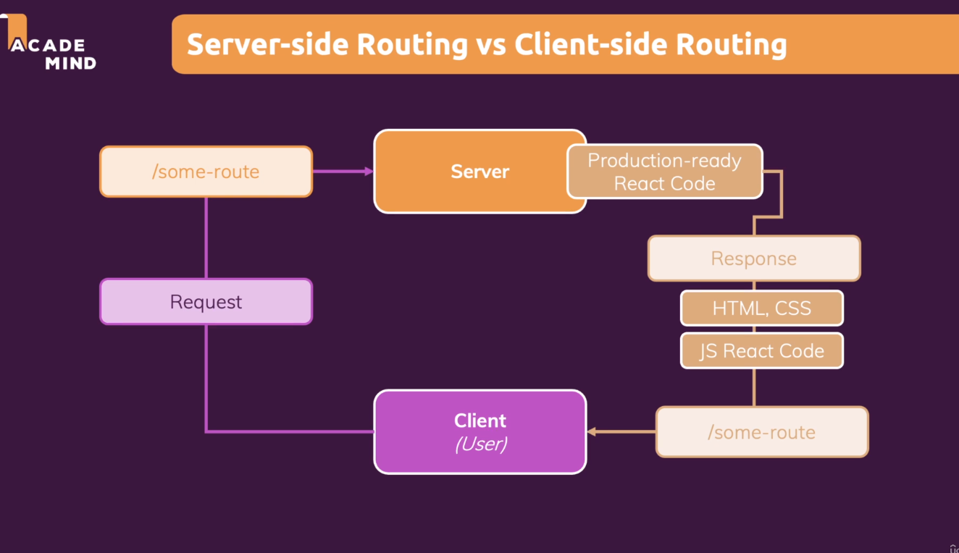

By default server does not ignore all the route paths mentioned after the domain. So we have to configure our routes accordingly.